INFORMATION RETRIEVAL:
IMPLEMENTATION OF HITS ALGORITHM

NAME | ID NUMBER
Meghana K | 2014B5A70932H
Kshitij Grovor | 2015A7PS0070H
Bhavathi Reddy | 2015A7PS0020H

ALGORITHM

The standard HITS algorithm has been implemented.

The hub array and the authority array are initialized and a power iteration method is employed.

- Updating the authority scores:
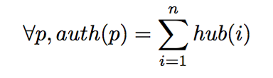
- Updating the hub scores:
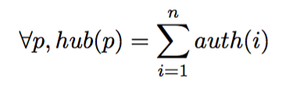
- Normalizing the authority scores
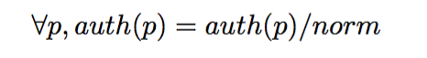
where
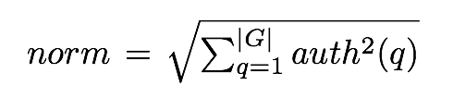
- Normalizing the hub scores
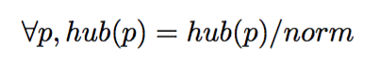
where
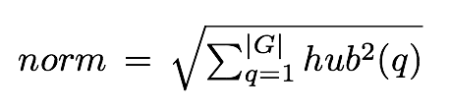
- Iterate

The following libraries have been used to implement a sparse matrix.

LIBRARIES USED

The standard HITS algorithm has been implemented.

numpy

sudo apt-get install python-numpy

scipy

sudo apt-get install python-scipy

matplotlab

sudo apt-get install python-matplotlib

networkx

pip install networkx

hits.py

The sparse matrix is formed from the scipy library.

The matrix multiplication is performed seamlessly with this library.

Top 20 hubs and authorities each have been plotted into a single plot after the algorithm runs till convergence.
The tolerence is considered as 1.0e-6.

Advantages

The HITS algorithm does not face the problem of spider traps and dead-ends as it uses the adjacency matrix and there are two pointers being calculated simultaneously, so all nodes are included.

Disadvantages

More recent documents might prove to be more relevant, the standard algorithm does not take care of that.

Time taken: 2sec

time.py

The enhancement aims to fix the disadvantage of HITS algorithm.
The timestamp of when the vote is cast, is used as a metric to determine relevance.

The time is measured from dummy current time.

The following formula is used as provided by a research paper in the Applied Mathematics and Information Sciences journal.

SJ=√12/(Y+1)

a(p)=∑ph(q)SJp

Time taken: 11sec
The hub equation is not changed because experts remain experts no matter how much time is passed. Hence, their reliability is retained. Only the authority matrix is altered.

